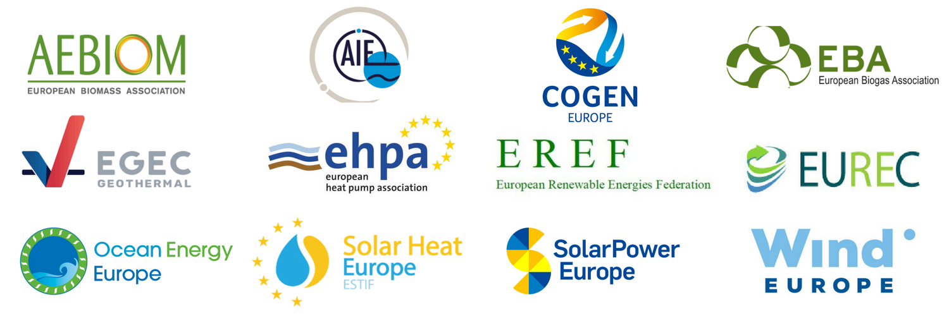

SMALL IS BEAUTIFUL
CALL FOR A « DE MINIMIS » APPROACH ON THE FRAMEWORK FOR SMALL RENEWABLES & COGENERATION INSTALLATIONS

The European Union has made a clear commitment to have global leadership in renewables and energy efficient solutions. The Clean Energy Package should be the main driver of this ambition.
To achieve this objective, the new Electricity Market Design framework must take a balanced approach appropriately recognizing the benefits of small scale, clean, and locally owned installations. These will be the backbone of a digitalized, decarbonized and increasingly distributed energy system, empowering energy consumers and territories (e.g. households, hospitals, public buildings, hotels, etc.).
The signatories of this declaration urge policy makers to acknowledge the specificities of small-scale renewable, and high efficiency cogeneration installations as well as demonstration projects, by strengthening the European Commission’s proposal on Article 4 paragraph 2 on balancing responsibilities and supporting Article 11 paragraph 2 and 3 on priority of dispatch for small installations, as part of the recast of the electricity market design regulation COM (2016) 861.
As assessed by the European Commission in its impact assessment on the Clean Energy Package, removing the current balancing responsibilities exemption regime and priority dispatch for small installations will result in heavy technical and administrative burdens on companies; and be prohibitive for small actors including small and medium sized enterprises (SMEs) who wish to engage in the energy transition.
The European Parliament’s current proposals for a re-designed electricity market expose small renewable and high efficiency cogeneration installations to the same market and balancing requirements as for utility-scale ones, with the result that small installations would be required to be “balancing-responsible” on the market and would no longer benefit from priority dispatch regimes.
A “de minimis” approach must be taken, exempting small-scale renewable and high efficiency cogeneration from disproportionate requirements such as compliance with balancing responsibilities, and keeping priority dispatch regimes post 2020.

SMALL IS BEAUTIFUL: A LOCALLY POWERED ENERGY TRANSITION

Small installations empower European citizens, communities and SME’s. Referring to small installations in Europe isn’t just a consideration of scale. These small installations are very diverse and reflect the commitment of European countries towards smarter distributed business models, empowering energy consumers (households, hospitals, public buildings, hotels) to produce their own sustainable heat and electricity.
Small generation installations empower territories: they create local jobs and contribute to rural development. The important variety of small scale installations directly benefit SMEs business activities, local communities and citizens to supply their heat and electricity needs from local energy sources. Sectors installing, maintaining and operating small scale installations are also important creators of local sustainable highly-skilled jobs that will make the green economy a local reality.
Proposals to remove priority dispatch for, and enforce balancing requirements on small installations will hinder the case for small distributed renewable and cogeneration installations to produce and consume sustainable electricity and heat in Europe.

Priority Dispatch
Most of the small installations are owned by households and small businesses for which market-based dispatch involves prohibitive technical and administrative burdens.
Operators of demonstration projects and small distributed installations should not be considered the same as large scale actors in the electricity system. Moreover, electricity markets are evolving in different ways in different Member States. Keeping the current priority dispatch and access regimes for small installations is fundamental for investors’ security, as they must cope with uncertainty in electricity markets.
An unconditional priority dispatch phase-out at the EU level, that ignores the specificities of the different European countries, is likely to stall the uptake of small renewable and cogenerated energy in countries where there has been little progress so far.
Balancing Obligations
Balancing and aggregation markets are not yet functioning in a way that can fairly expose small installations to balancing risks
Considering the specificity of business models for small installations (run by consumers, communities, farmers, cooperatives, SMEs, etc.), imposing balancing responsibility will increase administrative burden and costs for consumers or SMEs engaging in this business, as they will need to contract a third party (e.g. aggregator) to access balancing markets. Such requirements will hinder the uptake of small installations and new business models alike, as long as electricity markets do not provide efficient contracting of balancing and aggregation services, which is still the case in several EU Member States.

Removing priority dispatch and enforcing balancing requirements on small installations would be disproportionate and reduce the uptake of small renewable and cogeneration installations. This goes against the key pillars of the Clean Energy Package and the EU Energy Union, such as boosting energy efficiency, making Europe number one in renewable energy and empowering energy consumers.

Explicit Demand Response In Europe – Mapping the Markets 2017, SEDC

